Student: Advisor: Date: 12/23/2022

B.S. Information Sciences + Data Science (BSIS + DS)
Guide for course planning for the BS IS + DS Major. Meet with an iSchool Advisor to confirm requirements. https://ischool.illinois.edu/degrees-programs/undergraduate/bs-data-science

General Education Requirements
GenEds required of all undergraduate students at ILLINOIS,
managed by each college (iSchool requirements listed)
Some courses count as multiple GenEds and/or in IS Major
 | Composition I RHET or CMN or ESL |  |  |  | Quantitative Reasoning I & II |  |  | Completed with MATH 220/221/234 & STAT 107 & STAT 207
Advanced Composition
Take After Comp. I (IS 312 & INFO 303 approved)
 |  |  |  |  | Social & Behavioral Sciences
 | Western 1 Course (IS 266 Approved) |  |  |  | Completed with IS 101 & IS 202
 | Non-Western 1 Course |  |  |  | Language other than English  Third Level Required
 | U.S. Minority 1 Course
 |  |  |  |  | Complete > In-Progress ^Future Registered
 | Humanities & the Arts
 | 6 Hours Required (IS 312 approved; IS 142 approved for iSchool majors)
Natural Sciences & Tech
2 Courses Required

Information Sciences Core Requirements

 | IS 100 Exploring the iSchool with a Human-Centered Lens (First Semester) | INFORMATION SCIENCES ELECTIVES (24 hrs)
 | IS 101 Introduction to Information Sciences | IS/INFO Any Level (12 hr. 100 & above, may be INFO):
 | IS 202 Social Aspects of Info Technology (INFO 202) |  | [1] IS
 | IS 204 Research Design for Information Sciences |  | [2] IS
 | IS 206 Intro to Database Concepts & Applications |  | [3] IS
 | INFORMATION SCIENCES & CULTURE Select One: |  | [4] IS
 | IS 308 Race, Gender, & Information Technology | IS Advanced (12 hr. 300/400-level, must be IS):
 | IS 309 Computers & Culture |  | [5] IS
 | IS 310 Computing & Humanities |  | [6] IS
 | IS 311 Historical Foundations of the Info. Society |  | [7] IS
Additional IS 308-311 may be taken to count as IS electives |  |  | [8] IS
No substitutions in IS curriculum |  | DS Core Courses (listed below) do not count as IS Electives

Data Science Core Requirements

 | MATH 220 Calculus (or MATH 221 or MATH 234) | MEANINGFUL RESEARCH OR DISCOVERY (6 hrs)
 | MATH 227 or 257 Linear Algebra for DS/Computational Apps. | Select from experiences: IS 189/389 / INFO 199/399 Independent Study; IS 249 Practicum; IS 304 Adv. Research Design; IS 400 Colloquium; IS 199 E/EE Career Explore; IS 490 PSU Professional Skills; Study Abroad (LAS 291 & LAS 292)
 | STAT/IS/CS 107 Data Science Discovery
 | STAT 207 Data Science Exploration
 | CS 307 Modeling & Learning in Data Science
 | CS 277 Algorithms & Data Structures for Data Science (Sub: CS 225)
 | IS 467 Ethics & Policy for Data Science
 | IS 477 Data Management, Curation, & Reproducibility

Additional Requirements
123 Total Hours | Remaining: In-progress: Done: | Beginning Term: Expected Graduation:
21 Adv. Hours | 60 ILLINOIS Hours

Generic BSIS+DS Plan:
FA22 | SP23 |  | FA23 | SP24 |  | FA24 | SP25 |  | FA25 | SP26
RHET 105  IS 100  IS 101  IS 107  MATH 220 | IS 202 (3)  IS [1]  STAT 207  GenEds  Disc/Res. |  | IS 204  IS [2]  GenEds | MATH 227  IS 206  IS [3]  GenEds |  | IS 308-11  IS [4]  IS [5] Adv.C  GenEds | CS 277  IS 467  IS [6]  Disc/Res. |  | CS 307  IS [7]  Disc/Res. | IS 477  IS [8]  Disc/Res.
~14-16 hr. | ~14-17 hr. |  | ~14-17 hr. | ~14-17 hr. |  | ~14-17 hr. | ~14-17 hr. |  | ~14-17 hr. | ~14-17 hr.
Note: Some minors may require MATH 257 instead of MATH 227, but most students in +DS will take 227

Generic BSIS+DS Plan if CS Minor:
FA22 | SP23 |  | FA23 | SP24 |  | FA24 | SP25 |  | FA25 | SP26
RHET 105(4)  IS 100(1)  IS 101(3)  IS 107(4)  MATH 220(5) | IS 202 (3)  IS [1]  CS 124  GenEds  Disc/Res. |  | STAT 207  IS 204  IS [2]  CS 128  GenEds | MATH 227  IS 206  IS [3]  CS 173  GenEds |  | CS 307  IS 308-11  IS [4]  GenEds  CS 225 | IS [5] Adv.C  CS Adv.  Disc/Res. |  | IS 467  IS [6]  CS Adv.  Disc/Res. | IS 477  IS [7]  IS [8]  Disc/Res.
~14-16 hr. | ~14-17 hr.
CS Minor: Declare after 30 hours complete; Take CS 225 (not CS 277). You are not allowed to use CS 307 as one of the CS Minor Advanced Electives 3/400 level from CS Minor list (must have 6 distinct advanced hours for CS Minor that do not count in major).

Information Sciences (IS) Electives
There are a number of IS electives (100-400 level) to fulfill the 24 hr. requirement. Electives may be any course not listed in the IS/DS Core Requirements. Electives vary each semester in availability (check the Course Explorer each semester for current offerings). View all IS Courses here: http://catalog.illinois.edu/courses-of-instruction/is/
“Pathways” are areas of interest, & students may focus on one pathway, or across multiple. May align with careers and/or areas of interest. Students do not “declare” a pathway. https://go.ischool.illinois.edu/BSISpathways

Data Science Notes
Many courses require prerequisites and these should be closely followed. Please discuss course planning and degree requirements with an iSchool advisor.
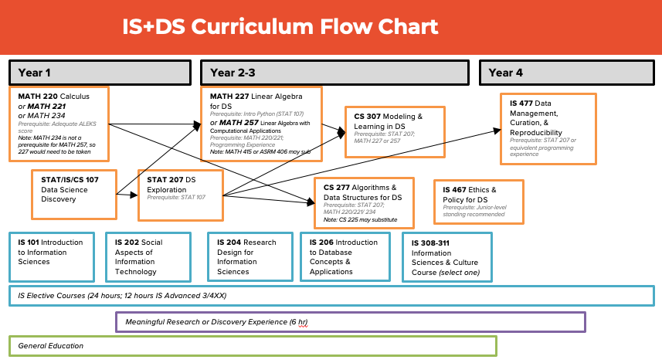
Current Course Offerings (may change over time, based on department offering course)
Course | Offering/Restrictions | Prerequisites
MATH 220  or 221 or 234 | Fall & Spring (& Summer)  AP or other credit & Proficiency credit good | Adequate ALEKS Score required
MATH 227  or MATH 257 | MATH 227 Spring Only – Designed for DS majors (majority should take)  MATH 257 Spring Better (Fall Restricted) – take 257 for some minors/dual-degrees/pre-requisites | MATH 227 Prerequisite: STAT 107  MATH 257 Prerequisite: MATH 220 or 221 & CS 101 or Equivalent programming experience
STAT/IS/CS 107 | Fall & Spring | No Prerequisites
STAT 207 | Fall & Spring | STAT 107
CS 307 | Fall Only | STAT 207 & One of: MATH 227, MATH 257, MATH 225, MATH 415, MATH 416, ASRM 406
CS 277  (*CS 225 may substitute) | CS 277 Spring Only  * CS 225 if CS Minor Fall & Spring | STAT 207; one of MATH 220, 221, or 234  Do not take CS 277 & CS 225 (one or other)  CS 225 requires CS 124, CS 128, CS 173, & MATH 220 or 221
IS 467 | Fall & Spring  Major Restriction | Junior or Senior Level
IS 477 | Fall & Spring  Major Restriction | STAT 207 & Junior or Senior Level

